S.HANSIKA
192421164
PSEUDO CODE

- Design a health and self-care mobile app that helps users maintain mental wellbeing with meditations and exercises. This case study talks you through the design process of creating a user- friendly mobile app. Design UI with the following requirements. • User Login ● Register ● Health Routine Blogs ● Self-Care Blogs
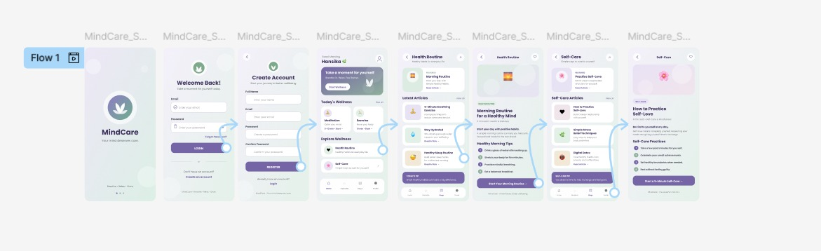
- This is an intelligent job assistant that helps users find their ideal job and get to all the way to signing a contract faster and more easily. Design UI with the following requirements. ● User Login ● Register Subscription • Personal Detail • Resume Upload • Choosing Job
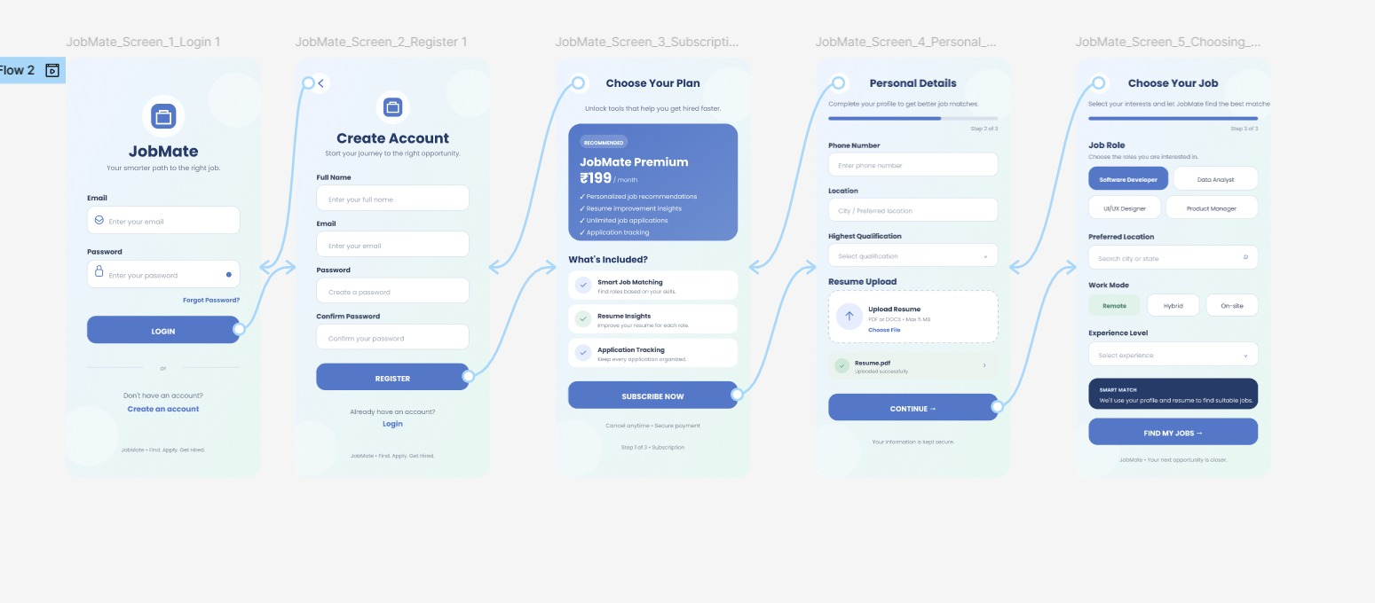

- This is a mobile app that can help people get parking slots easily even when they travel beyond their normal routes. Design UI with the following requirements. ● UserLogin ● Register Count of Empty Parking ● Free Parking Slots Display ● Booking Parking Slots

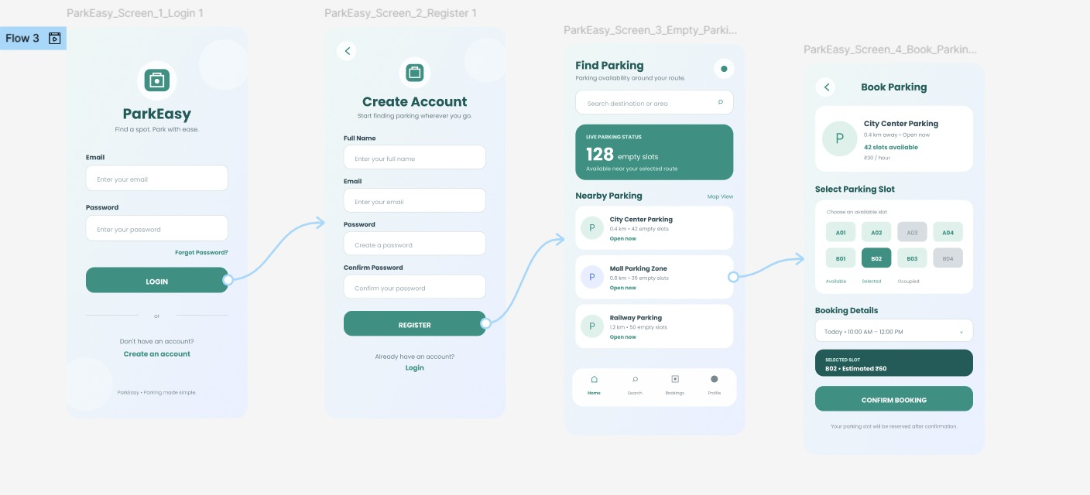
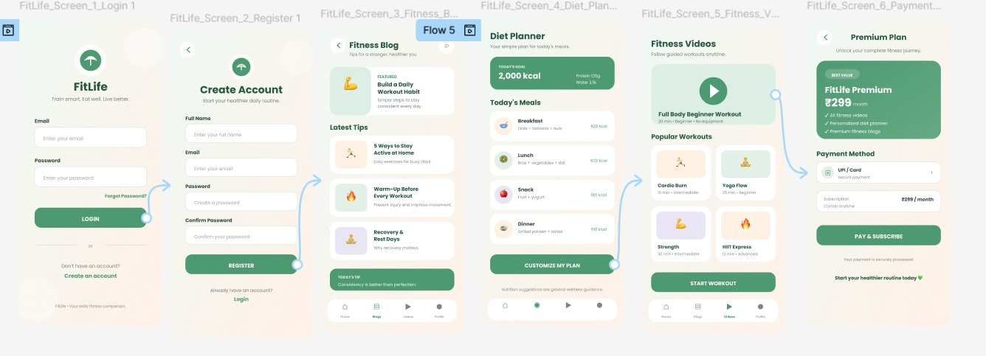
4.Design a mobile app for Online Body Fitness tips and videos for a good daily routine. Contains the following requirements. User Login ● Register ● Fitness Blog ● Diet Planner ● Fitness Videos ● Payment and Subscription.
FIGMA LINK :(FOR ALL QUESTIONS )
https://www.figma.com/design/uPUI1V3Q9KHTsQqmPmbmBi/Untitled?node-id=0-1&p=f&t=FN9qSSaX6keAS6bn-0

